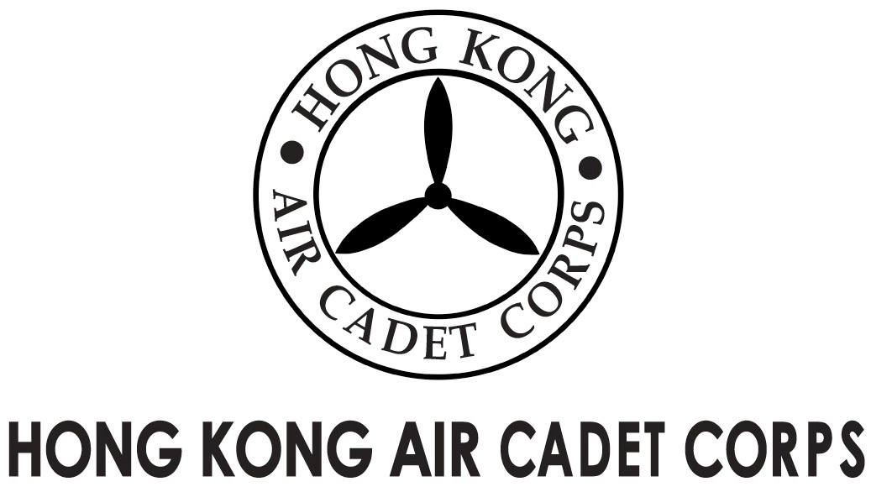
ADMINISTRATION AND SUPPORT GROUP.

From | OC PA Flt  Saki L W LEE  (sakilee0906@gmail.com) | To  Copy to | OC No. 102, 107, 108 & 408  Major Unit Commanders
Our Ref | GOSA/2018/2 | # of Pages | 1
Date | 7-Dec-2018 | Your Ref

Grantham Uniformed Youth Groups Outstanding Service Award
葛量洪青少年制服團隊傑出服務獎
Invitation for Interviews

Please take note that the following cadets nominated for the caption award are invited to attend an interview at HQ workshop on 16-Dec-2018 (Sunday).

Rank and Name Interview Time
Cpl CHAI Nok-ming 1000 – 1015 hrs
FS LEE Hin-yat 1015 – 1030 hrs
Cpl LI Siu-ming 1030 – 1045 hrs
Cpl LI Yat-long 1045 – 1100 hrs
Sgt MOK Chun-yiu Jonathan 1100 – 1115 hrs

The dress code is No.2A or 2B. Please report to the venue 10 minutes before your allotted time.

Yours sincerely,

Saki L W LEE
Flying Officer OC PA Flt

